**Ex:9**

Create a React Application named “cricketapp”

**ListofPlayers.js**

import React from "react";

const players = [

{ name: "Virat", score: 80 },

{ name: "Rohit", score: 65 },

{ name: "Dhawan", score: 72 },

{ name: "Rahul", score: 55 },

{ name: "Jadeja", score: 90 },

{ name: "Pant", score: 60 },

{ name: "Ashwin", score: 75 },

{ name: "Bumrah", score: 40 },

{ name: "Shami", score: 68 },

{ name: "Surya", score: 95 },

{ name: "Kuldeep", score: 50 },

];

const ListofPlayers = () => {

// Map to show all players

const allPlayers = players.map((player, index) => (

<li key={index}>

{player.name} - {player.score}

</li>

));

// Filtered using arrow function

const lowScorers = players.filter(p => p.score < 70);

return (

<div>

<h2>All Players</h2>

<ul>{allPlayers}</ul>

<h3>Players with Score &lt; 70</h3>

<ul>

{lowScorers.map((p, idx) => (

<li key={idx}>{p.name} - {p.score}</li>

))}

</ul>

</div>

);

};

export default ListofPlayers;

**IndianPlayers.js**

// src/IndianPlayers.js

import React from "react";

const IndianPlayers = () => {

const oddPlayers = ["Virat", "Dhawan", "Jadeja"];

const evenPlayers = ["Rohit", "Rahul", "Pant"];

// Destructuring

const [odd1, odd2, odd3] = oddPlayers;

const [even1, even2, even3] = evenPlayers;

// Merge arrays

const T20players = ["Gill", "Iyer"];

const RanjiTrophy = ["Pujara", "Rahane"];

const merged = [...T20players, ...RanjiTrophy];

return (

<div>

<h2>Odd Team Players</h2>

<ul>

<li>{odd1}</li>

<li>{odd2}</li>

<li>{odd3}</li>

</ul>

<h2>Even Team Players</h2>

<ul>

<li>{even1}</li>

<li>{even2}</li>

<li>{even3}</li>

</ul>

<h2>Merged Players (T20 + Ranji)</h2>

<ul>

{merged.map((player, index) => (

<li key={index}>{player}</li>

))}

</ul>

</div>

);

};

export default IndianPlayers;

**App.js**

import React from "react";

import ListofPlayers from "./ListofPlayers";

import IndianPlayers from "./IndianPlayers";

function App() {

const flag = true; // change to false to test the other component

return (

<div className="App">

<h1>Cricket App</h1>

{flag ? <ListofPlayers /> : <IndianPlayers />}

</div>

);

}

export default App;

**Output Screenshot:**

When flag = true

When flag = false

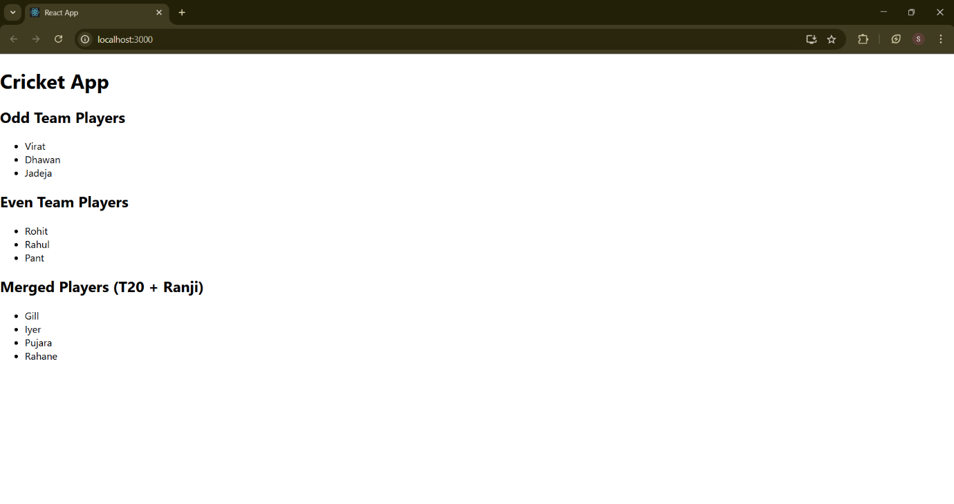

**Ex:10**

**App.js**

// src/App.js

import React from "react";

import officeImage from "./assets/rentalimage.jpeg";

function App() {

  const officeList = [

    {

      name: "SpaceOne",

      rent: 55000,

      address: "1st Floor, TechPark, Bangalore",

      image: officeImage,

    },

    {

      name: "BizNest",

      rent: 75000,

      address: "2nd Floor, Infocity, Hyderabad",

      image: officeImage,

    },

    {

      name: "WorkHub",

      rent: 60000,

      address: "3rd Floor, CyberCity, Pune",

      image: officeImage,

    },

  ];

  // Heading element

  const heading = <h1 style={{ textAlign: "center" }}>Office Space Rental App</h1>;

  return (

    <div style={{ padding: "20px" }}>

      {heading}

      <div style={{ display: "flex", flexDirection: "column", gap: "20px" }}>

        {officeList.map((office, index) => {

          const rentStyle = {

            color: office.rent < 60000 ? "red" : "green",

            fontWeight: "bold",

          };

          return (

            <div key={index} style={{ border: "1px solid #ccc", padding: "15px", borderRadius: "8px" }}>

              <img src={office.image} alt={office.name} style={{ width: "100%", maxWidth: "300px" }} />

              <h2>{office.name}</h2>

              <p style={rentStyle}>Rent: ₹{office.rent}</p>

              <p>Address: {office.address}</p>

            </div>

          );

        })}

      </div>

    </div>

  );

}

export default App;

Output Screenshot:

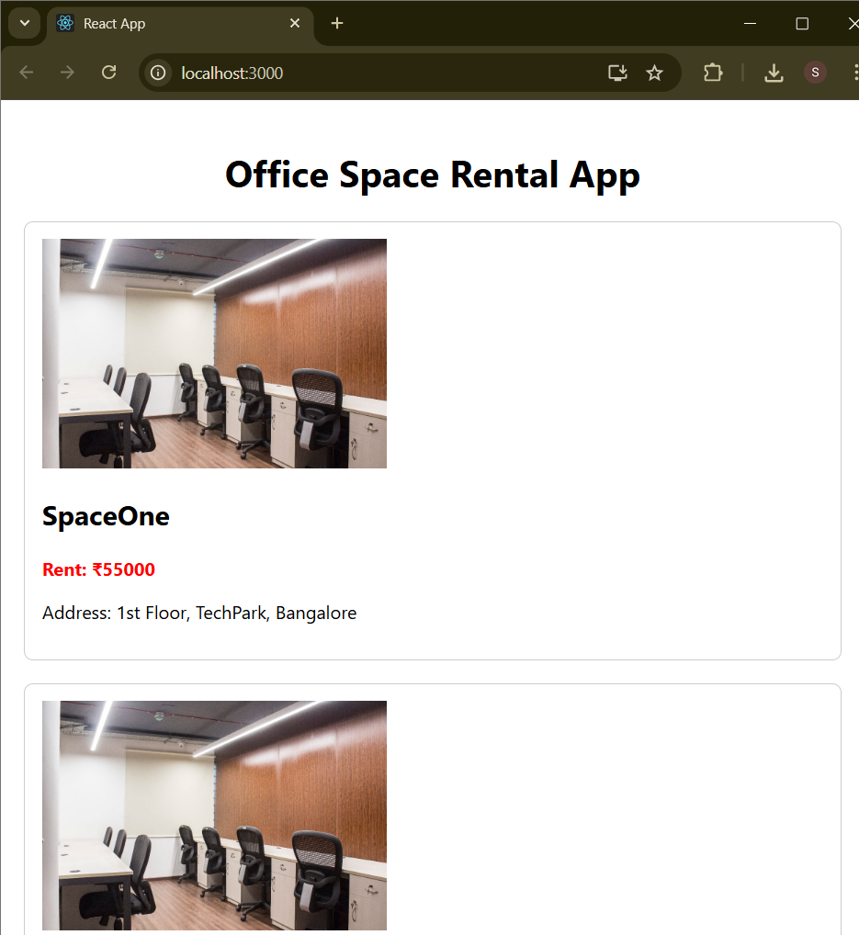

**Ex:11**

**App.js**

import React, { useState } from "react";

import CurrencyConvertor from "./CurrencyConvertor";

function App() {

  const [count, setCount] = useState(0);

  const increment = () => {

    setCount(prev => prev + 1);

    sayHello();

  };

  const decrement = () => {

    setCount(prev => prev - 1);

  };

  const sayHello = () => {

    console.log("Hello! This is a static message.");

  };

  const sayWelcome = (msg) => {

    alert("Welcome message: " + msg);

  };

  const handleSyntheticEvent = (e) => {

    // e is a synthetic event

    console.log("Synthetic Event Object:", e);

    alert("I was clicked");

  };

  return (

    <div style={{ padding: "30px" }}>

      <h1>Event Handling Examples</h1>

      <h2>Counter: {count}</h2>

      <button onClick={increment}>Increment</button>{" "}

      <button onClick={decrement}>Decrement</button>

      <br /><br />

      <button onClick={() => sayWelcome("welcome")}>Say Welcome</button>

      <br /><br />

      <button onClick={handleSyntheticEvent}>Synthetic OnPress</button>

      <br /><br />

      <CurrencyConvertor />

    </div>

  );

}

export default App;

**CurrencyConvertor.js**

// src/CurrencyConvertor.js

import React, { useState } from "react";

function CurrencyConvertor() {

  const [rupees, setRupees] = useState("");

  const [euro, setEuro] = useState("");

  const handleSubmit = (e) => {

    e.preventDefault();

    if (!isNaN(rupees)) {

      const result = (parseFloat(rupees) * 0.011).toFixed(2);

      setEuro(result);

    } else {

      alert("Please enter a valid number");

    }

  };

  return (

    <div style={{ marginTop: "30px" }}>

      <h2>Currency Converter</h2>

      <form onSubmit={handleSubmit}>

        <input

          type="text"

          value={rupees}

          placeholder="Enter INR"

          onChange={(e) => setRupees(e.target.value)}

        />

        <button type="submit">Convert</button>

      </form>

      {euro && <p>{rupees} INR = {euro} EUR</p>}

    </div>

  );

}

export default CurrencyConvertor;

**Output Screenshot:**

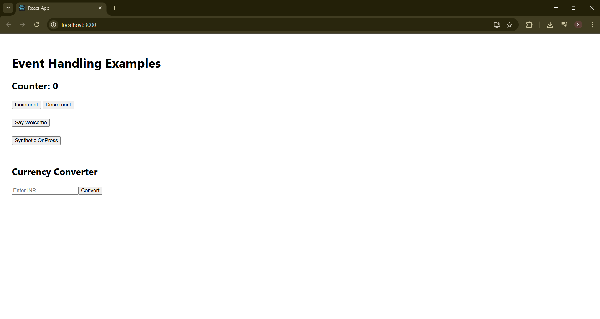

**Ex:12**

**GuestPage.js**

import React from "react";

function GuestPage() {

return (

<div>

<h2>Welcome, Guest!</h2>

<p>Here are some available flights:</p>

<ul>

<li>Flight A - 10:00 AM</li>

<li>Flight B - 2:30 PM</li>

<li>Flight C - 6:45 PM</li>

</ul>

</div>

);

}

export default GuestPage;

**UserPage.js**

import React from "react";

function UserPage() {

return (

<div>

<h2>Welcome, User!</h2>

<p>You are now logged in. Book your tickets below:</p>

<form>

<label>

Select Flight:

<select>

<option>Flight A</option>

<option>Flight B</option>

<option>Flight C</option>

</select>

</label>

<br /><br />

<button type="submit">Book Ticket</button>

</form>

</div>

);

}

export default UserPage;

**App.js**

import React, { useState } from "react";

import GuestPage from "./GuestPage";

import UserPage from "./UserPage";

function App() {

const [isLoggedIn, setIsLoggedIn] = useState(false);

// Element variable (can hold component)

let content;

if (isLoggedIn) {

content = <UserPage />;

} else {

content = <GuestPage />;

}

return (

<div style={{ padding: "20px", fontFamily: "Arial" }}>

<h1>Ticket Booking App</h1>

<button onClick={() => setIsLoggedIn(!isLoggedIn)}>

{isLoggedIn ? "Logout" : "Login"}

</button>

<hr />

{/* Conditional content rendering */}

{content}

</div>

);

}

export default App;

**Output Screenshot:**



